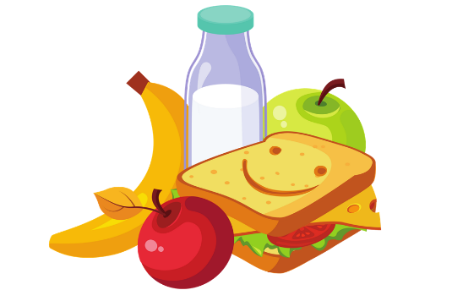
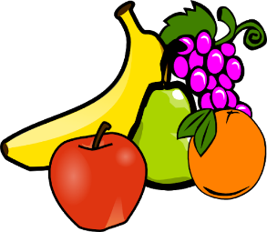
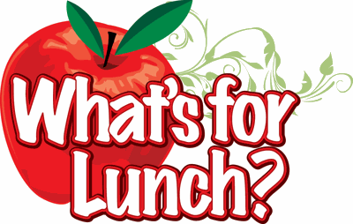
Monday
Kid’s World Menu Week 3
Breakfast | AM Snack | Lunch | PM Snack
Dairy – 1% Milk  Fruit – Orange Slices  Grain – Cereal | Dairy – 1% Milk  Cinnamon Toast | Cowboy Stew  Meat – Ground Beef  Vegetable – Mixed Veggies  Fruit – Pears | Drink – Water  Dairy – Cheese Slices  Grain – Wheat Crackers
Tuesday  Dairy – 1% Milk  Fruit – Applesauce  Grain – Pancakes | Dairy – 1% Milk  Dairy – Yogurt  Grain – Cheerios | Spaghetti  Meat – Ground Beef  Grain – Pasta  Vegetable – Green Beans  Fruit – Peaches | Dairy – 1% Milk  Grain – Animal Crackers
Dairy – 1% Milk  Wednesday  Egg & Cheese Omelette  Grain – Toast | Drink – Water  Vegetables – Carrots  Grain – Wheat Crackers | Taco Salad w/Cheese  Meat – Beef  Vegetables – Lettuce & Corn  Fruit – Pineapple | Drink – Water  Grain – Goldfish
Dairy – 1% Milk  Thursday  Sausage & Biscuit  Fruit – Orange Slices | Dairy – 1% Milk  Grain – Muffins  Fruit – Applesauce | Beanie Weenies  Meat – Hot dogs / Beans  Grain – Bread  Vegetable – Mixed Veggies  Fruit – Mixed Fruit | Dairy – 1% Milk  Grain – Graham Crackers
Dairy – 1% Milk  Friday  French Toast  Fruit – Bananas  Milk served with all lunches | Dairy – 1% Milk  Dairy – Yogurt  Grain – Cheerios | Cheese Pizza  Meat & Grain-Cheese & Pizza  Crust  Vegetables – Carrot Sticks  Fruit – Apple Slices | Fruit – Apple Juice  Grain – Wheat Crackers
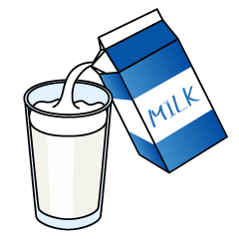
Whole milk served to children under 2 not on formula

