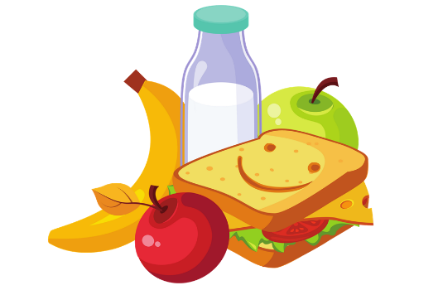
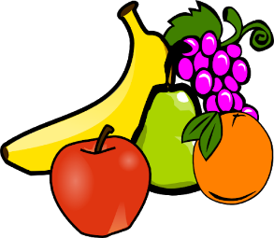
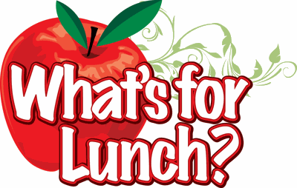
Kid’s World Menu Week 1
Breakfast | AM Snack | Lunch | PM Snack
Dairy – 1% Milk  Monday  Fruit – Orange Slices  Grain – Cereal | Dairy – 1% Milk  Cinnamon Toast | Chicken & Broccoli Pasta  Meat – Chicken  Grain – Pasta  Vegetable – Broccoli  Fruit – Peaches | Drink – Water  Dairy – Cheese Slices  Grain – Wheat Crackers
Tuesday  Dairy – 1% Milk  Fruit – Applesauce  Grain – Pancakes | Dairy – 1% Milk  Dairy – Yogurt  Grain – Cheerios | Beefy Nachos  Meat alt – Cheese  Meat – Ground Beef  Vegetable – Corn  Fruit – Pears | Dairy – 1% Milk  Grain – Animal Crackers
Dairy – 1% Milk  Wednesday  Egg & Cheese Omelette  Grain – Toast | Drink – Water  Vegetables – Carrots  Grain – Wheat Crackers | Chicken Tacos  Meat – Chicken  Grain – Tortilla  Vegetables – Mixed Veggies  Fruit – Mixed Fruit | Drink – Water  Grain – Goldfish
Dairy – 1% Milk  Thursday  Sausage & Biscuit  Fruit – Orange Slices | Dairy – 1% Milk  Grain – Muffins  Fruit – Applesauce | Beefy Mac  Meat – Ground Beef  Grain – Macaroni and Cheese  Vegetable – Green Beans  Fruit – Pineapple | Dairy – 1% Milk  Grain – Graham Crackers
Dairy – 1% Milk  Friday  French Toast  Fruit – Bananas | Dairy – 1% Milk  Dairy – Yogurt  Grain – Cheerios | Turkey Sandwich  Meat – Turkey  Grain – Bread  Vegetables – Carrot Sticks  Fruit – Apple Slices | Fruit – Apple Juice  Grain – Wheat Crackers
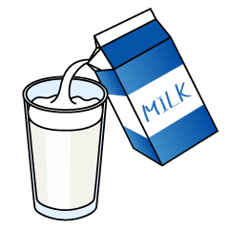
Milk served with all lunches
Whole milk served to children under 2 not on formula

